**Customer management System – User Manual**

1. **Frontend : React.js with JWT Authentication**
2. **Backend : Dot Net Core – Web API – Clear Architecture**

**I. Frontend – React.js**

enter username and password it go api, api validate username and password then get JWT token and save it in localStorage then redirect to Customer List page

Login Page:

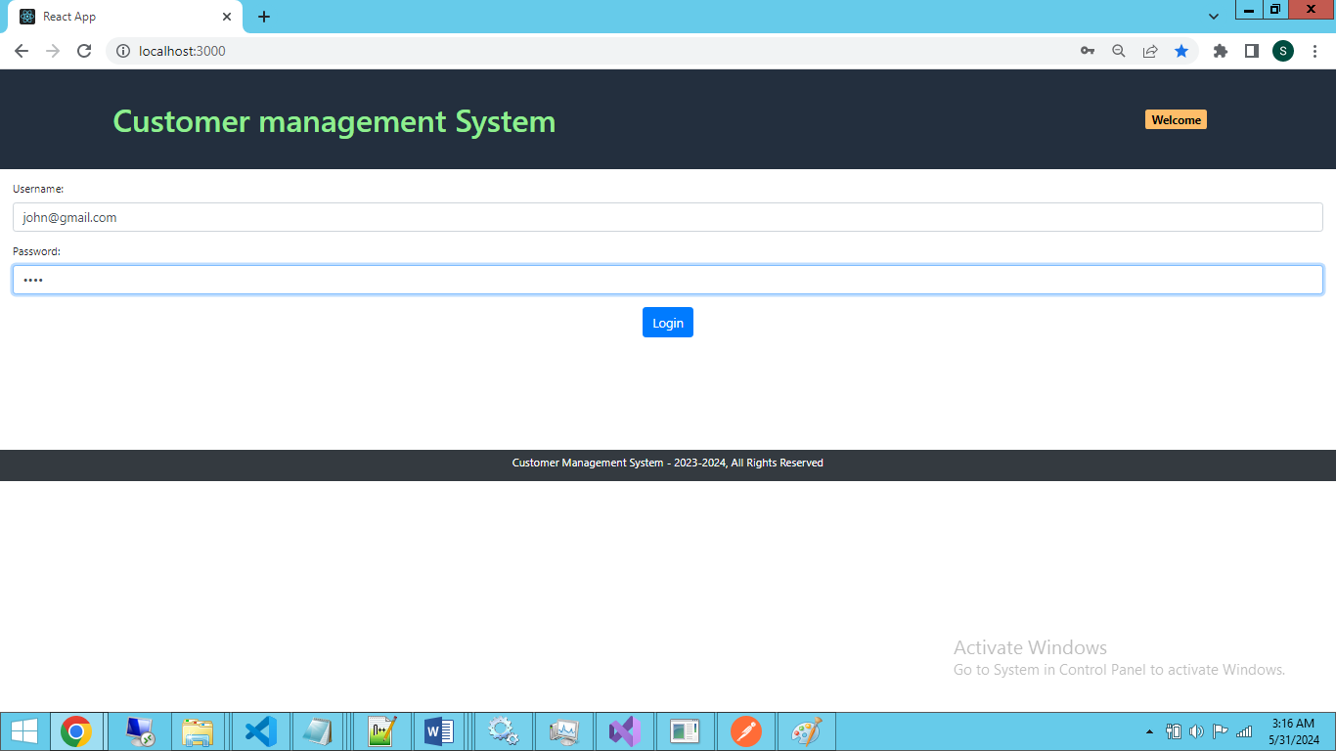

Cusomer List Page: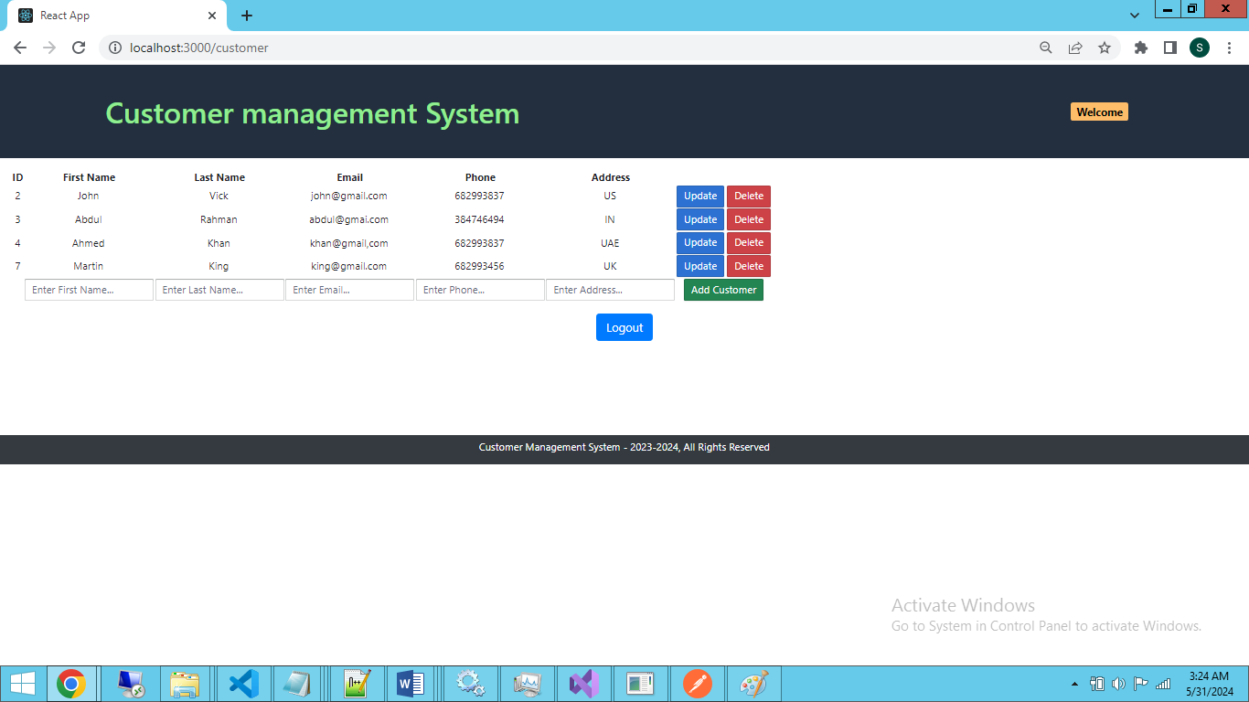

**II. Backend : Dot Net Core – Web API - Url**

<https://localhost:7067/swagger/index.html>

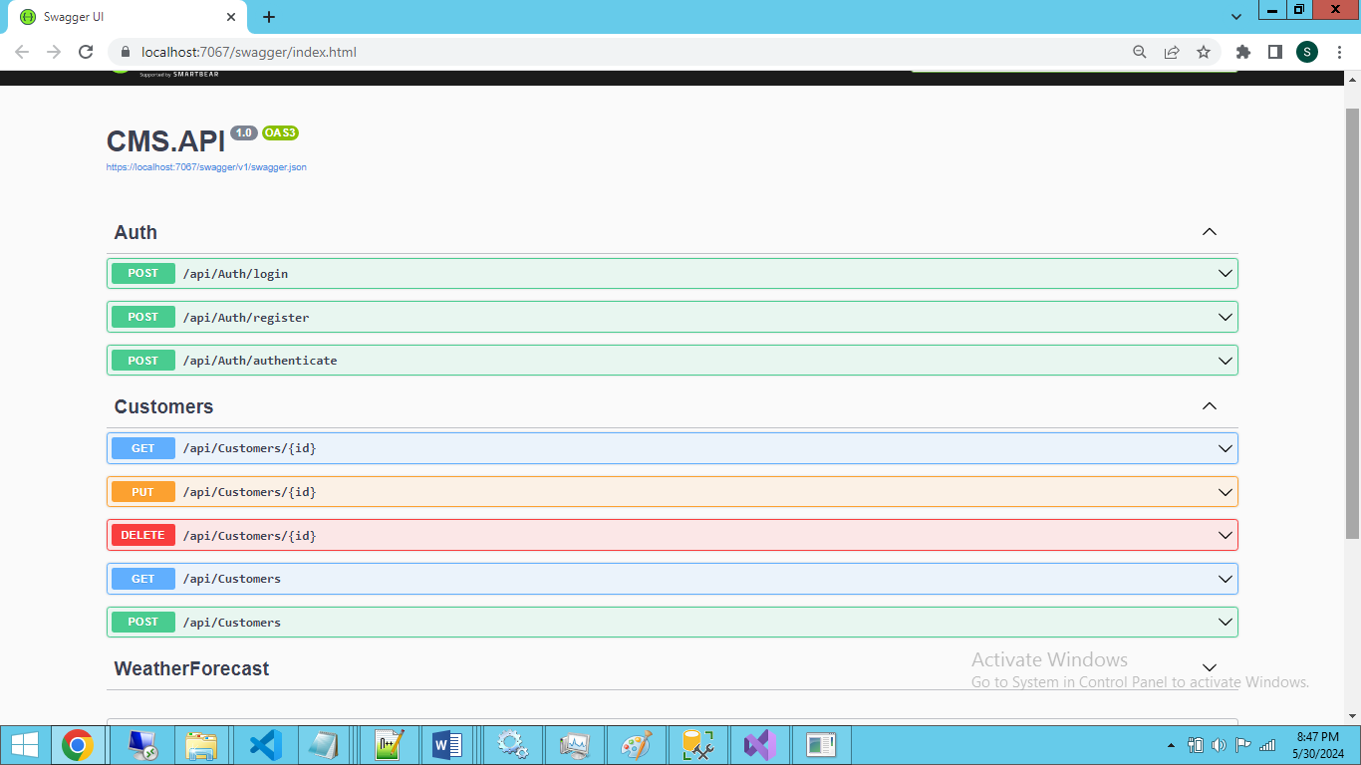

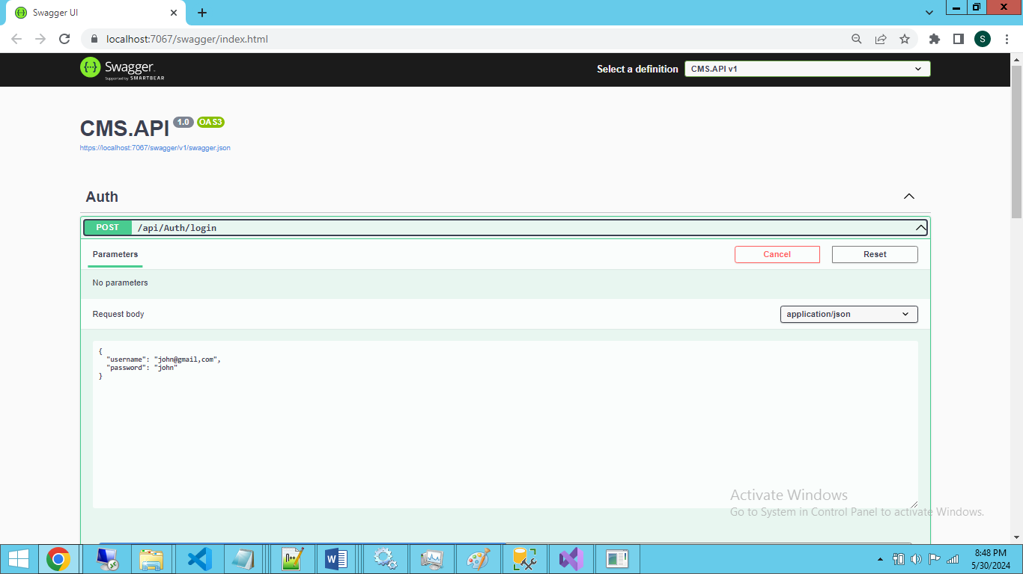 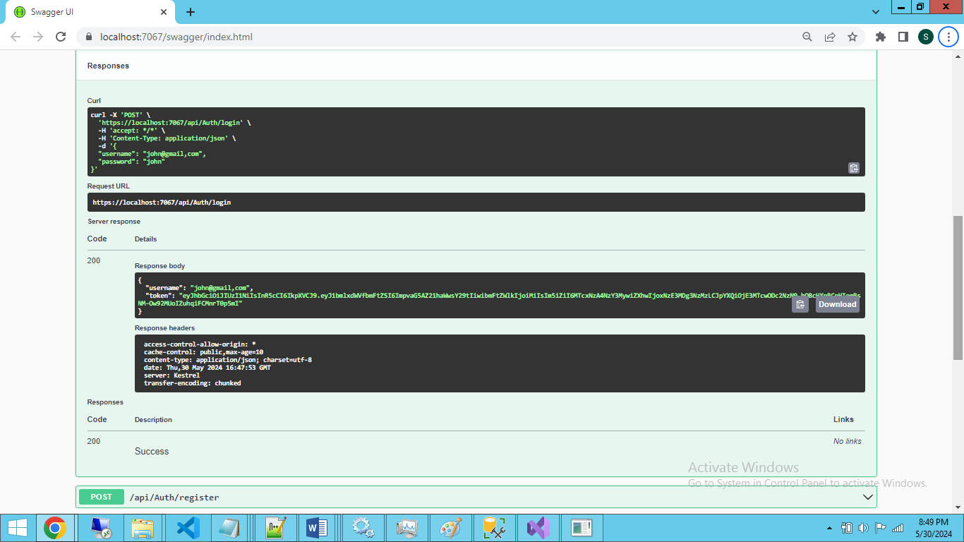 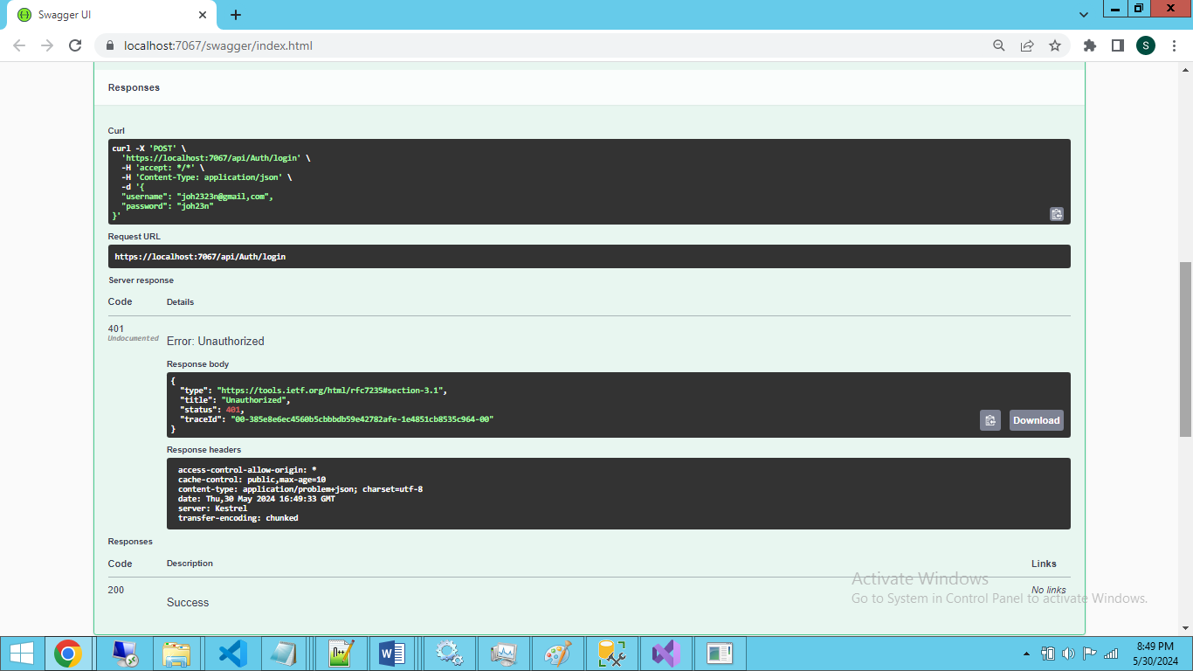

Login by using username and password: End Point: <https://localhost:7067/api/Auth/login>

{

    "username": "john@gmail.com",

    "password": "john"

}

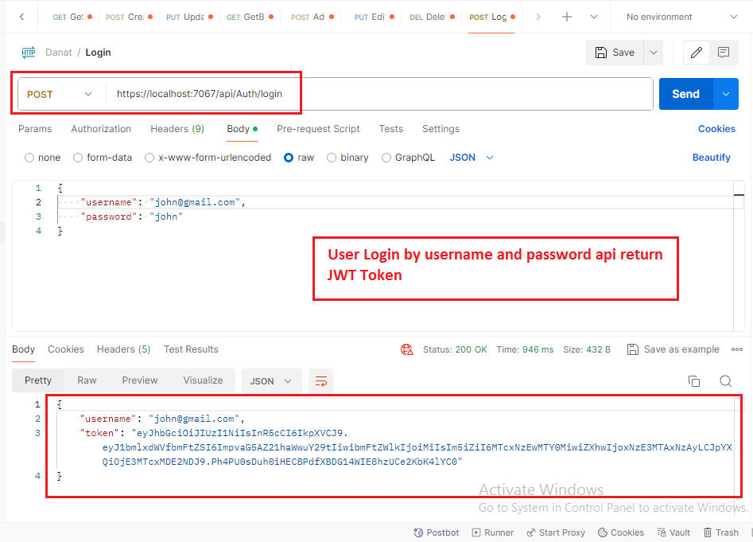

**Customer End Points:**

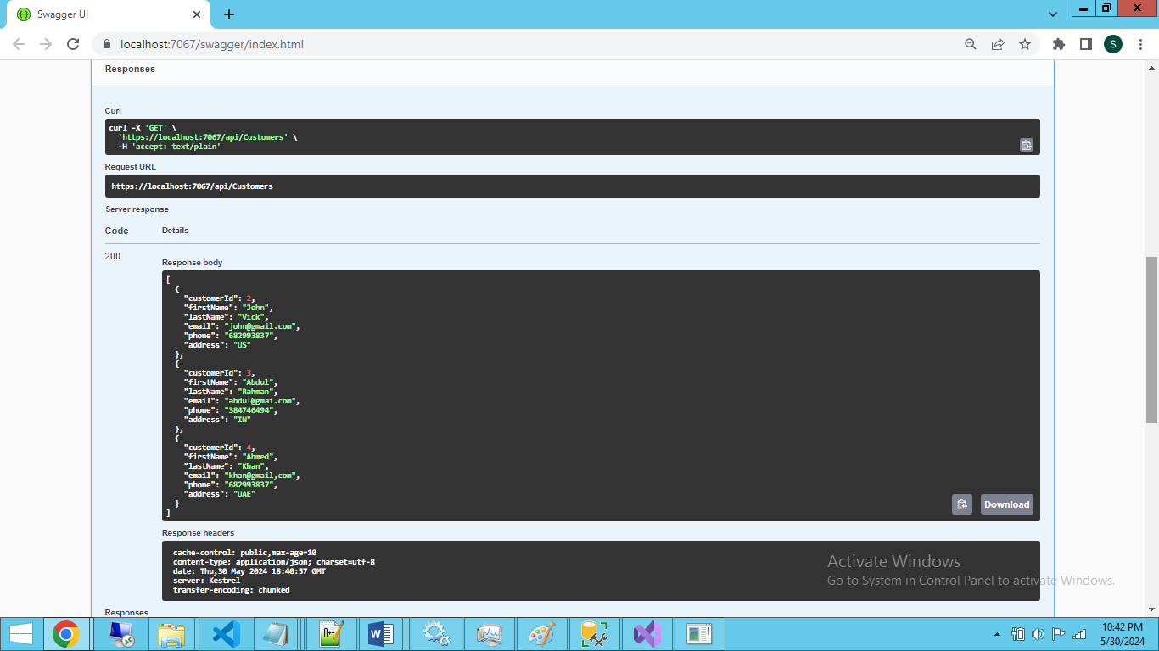

<https://localhost:7067/api/Customers>

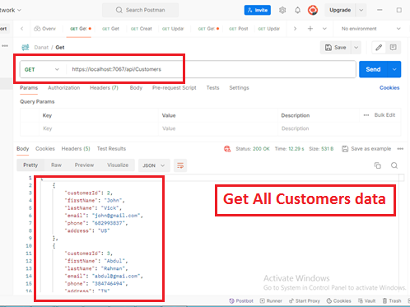

<https://localhost:7067/api/Customers/2>

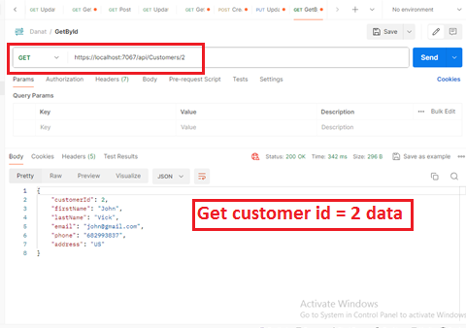

Added below Customer: End Point - POST: https://localhost:7067/api/Customers

{

    "firstName": "Martin",

    "lastName": "Luther",

    "email": "martin@gmail.com",

    "phone": "682993456",

    "address": "USA"

}

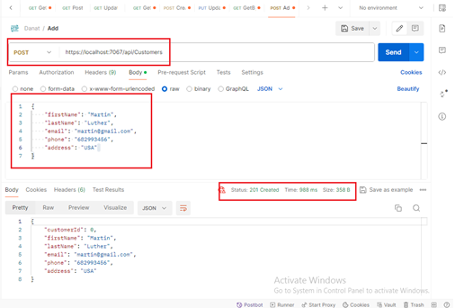

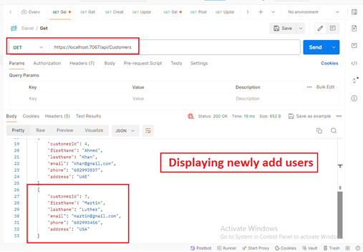

End point – PUT : https://localhost:7067/api/Customers/7

{

    "customerId":"7",

    "firstName": "Martin",

    "lastName": "King",

    "email": "king@gmail.com",

    "phone": "682993456",

    "address": "UK"

}

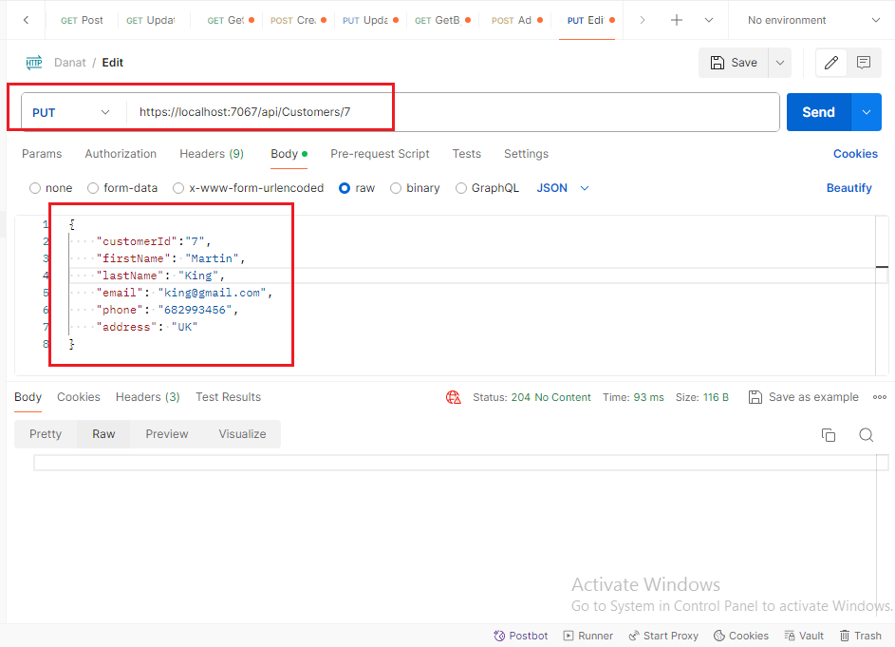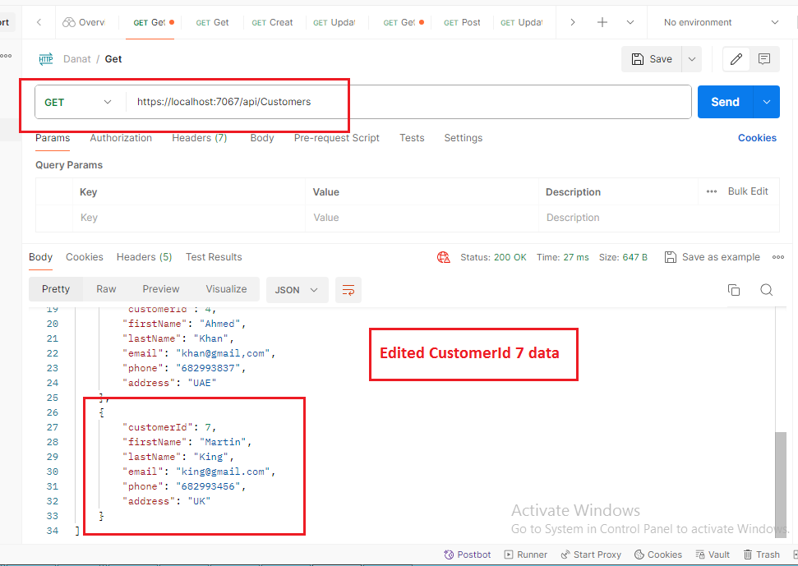

Deleted Customer Id =7 data : End Point-Delete: https://localhost:7067/api/Customers/7

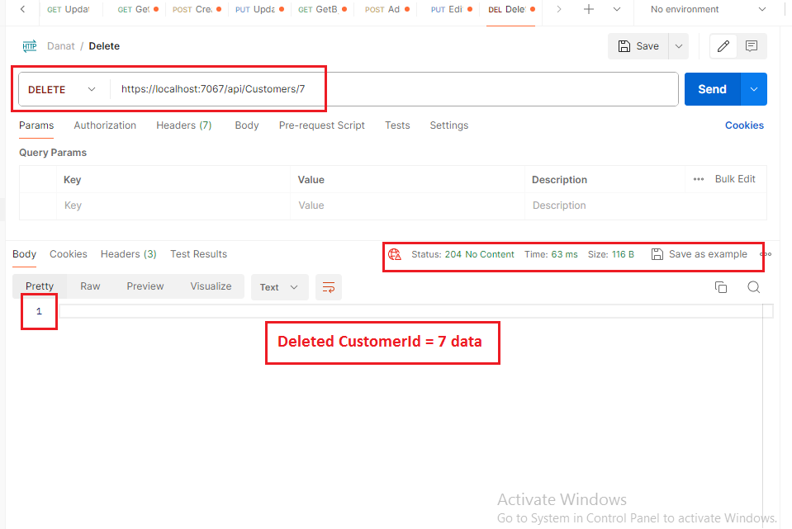

Frontend – React.js

enter username and password it go api, api validate username and password then get JWT token and save it in localStorage then redirect to Customer List page

Login Page:



Cusomer List Page: